3 system architecture

The City Smart Guys have chosen to use a N-tier software architecture as part of the Django software. Django uses a high-level 3-tier architecture “Client-Server” Architecture, where all the modules such as: logic data access, computer data storage and user interface are all separate and independent processes. In a real world application, this allows developers to update different parts of the software to be changed one part at a time, and if something was to go wrong, it can be easily fixed without the rest of the system crashing with it.

Figure - 3 Tier architecture for Django Applications

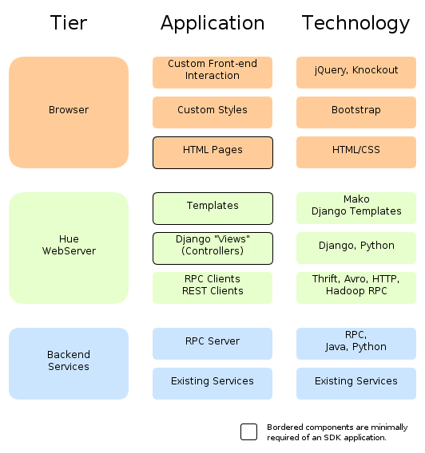

Reference: Architecture by Hue SDK Documentation

The overview of the system for our website is that the client side will be access through a web browser and HTML coding. The middleware side of the system is the Django applications, such as the authentication application for logging into user accounts and registering new users. It has a built-in development webserver which will allow the client to be able to access the files during the creation of the website. The database level has been built using SQLite 3 and the search API is done through Bing Search.